Society Awareness for Elders During the COVID-19 Pandemic

It is important for individuals in society to be aware of issues the elderly population faces during this traumatic time. The elder population is at higher risk for contracting the virus.

Why is the COVID-19 problematic for elders?
Lack of knowledge about the full range of services. There are 8 out of 10 COVID – 19 reported deaths in the U.S. of elders 65 and older. Elders 85 and older are at greater risk for severe illness from COVID-19.

Causes of Isolation

- Living alone causes isolation. If seniors have symptoms, they can call 911, which directs them to available resources, such as 24-hour helplines, for counselors to help them.

- Limited access to items. Seniors are recommended to stay indoors and not go out in public during the pandemic. This makes it difficult to obtain important necessities.

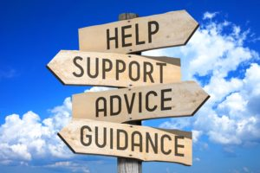
- Restricted visitors: seniors in assisted living homes are not allowed to have visitors. [Source: www.Agewell.com]

